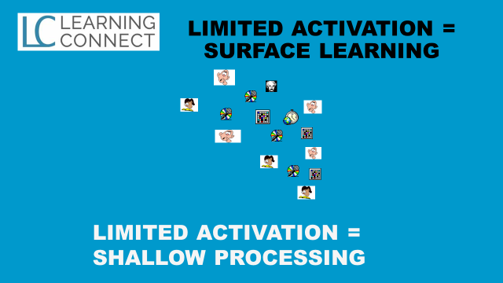

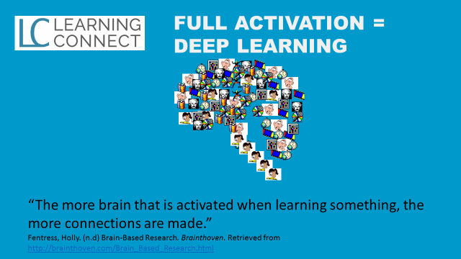
(Improve Focus and Concentration Skills, Memory Skills, Listening and Reading Skills, Speaking and Writing Skills, Critical Thinking and Problem-Solving Skills, Planning, Process and Procedures Skills, Social and Collaboration Skills)

