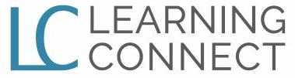

“An Online Instructional System for Raising Student Achievement”
Testimonial Release Form
Please download and complete the following Learning Connect Testimony Release form so your experience can be shared with other educators in the endeavor to raise student achievement and create student success.
Date __________________
Testimonial Statement and/or Inventory of Testimonial Materials:

Authorization and Release Information
I authorize Learning Connect to use the above Testimonial for purposes of publicizing the Learning Connect modules and or for any other lawful purpose. These statements may be used in printed publications, multimedia presentations, on websites or in any other distribution media. I agree that I will make no monetary or other claim against Learning Connect for the use of the statement.
Signature: ______________________________________________________________
I have read the authorization and release information and give my consent for the use as indicated above.
Printed Name: _________________________________________
Signature: _________________________________________
Return Instructions: Please attach document to an email and return to learningconnect@att.net

